API Development Guide
for HF Reader
V4.1.3
Contents
1. Summarize 4
2.1. General Structure 5
2.2. Layer#1 :Device Drivers 6
2.3. Layer#2: Device Common Programming Interface 7
2.4. Layer#3: Air protocol interface 8
2.4.1. Description 8
2.4.2. Supported air protocol interface 8
3. Directory navigation 9
3.1. doc 9
3.2.samples 9
4. API calling step 10
4.1. Open reader driver 10
4.2. RFID Reader Operation 11
4.2.1 Tag Inventory 11
4.2.2 RFID Tag Access 12
4.2.2.1. Access ISO5693 tag Step 12
4.2.2.2 ISO14443A - Access Mifare Utralight Step 13
4.2.2.3 ISO14443A - Access Mifare classic (S50/S70) Step 14
4.3. NFC APIs 15
4.3.1 write NDEF message to tag 15
4.3.2 read NDEF message from tag 16
4.4. Close reader driver 17
4.5. ISO15693 tag access C++ example 18
4.6. ISO14443A-Mifare S50 C++ example 20
5. Connection String 22
5.1. Description 22
5.2. Build connection string of serial port 23
5.2.1. Format example 23
5.2.2. Parameter description 23
5.3. Build connection string of USB 24
5.3.1. Format example 24
5.3.2. Parameter description 24
5.4. Build connection string of network 25
5.4.1. Format example 25
5.4.2. Parameter description 25
5.5. Build connection string of Bluetooth 26
5.5.1. Format example 26
5.5.2. Parameter description 26
6. Description of common API calls for the rfidlib_reader.dll 27
6.1. Enumerate serial ports 27
6.1.1. API Introduction 27
6.1.2. C# programming example 27
6.2. Enumerate the inserted USBHID Readers 28
6.2.1. API introduction 28
6.2.2. C# programming example 28
6.3. Enumerate the matched Bluetooth readers 29
6.3.1. API introduction 29
6.3.2. C# programming example 29
6.4. Enumerates the loaded RFID reader driver 30
6.4.1. API introduction 30
6.4.2. C# Programming example 30
6.5. RS485 Bus programming 32
6.5.1. Description 32
6.5.2. C++ programming example 32
6.6. GPIO output control 34
6.6.1. API introduction 34
6.6.2. API calling process 34
6.6.3. C++ programming example 36
6.7. Get Input GPIO status 37
6.8. Get device information 37
6.9. Read/write configuration block 37
6.10. To fetch buffer record in Buffer mode 38
Appendix 1. RFIDLIB variable type 39
1.1. Variable Type Description 39
1.2. Variable type defined in C++ 40
1.3. Variable type defined in C# 41
1.4. Variable type defined in delphi 42
1.5. Variable type defined in VB 43
1.6. Variable type defined in VB.net 44
Appendix 2. Air protocol type and Tag type coding 45
2.1.Air protocol type code definition 45
2.2. Tag type code definition 46
2.2.1. ISO15693 46
2.2.2. ISO14443A 46
Appendix 3. RFIDLIB API error table 47

1. Summarize
According to different RFID reader types we have defined the reader driver interface, each RFID reader has its corresponding driver. Such as the PCI adapter on the computer motherboard, you can connect to hardware which support PCI standard.
According to RFID ISO15693 ,ISO14443B and ISO14443A standards, we define RFID tags access APIs , making the application layer program accessing RFID tags become standardized. In the replacement of the RFID reader, only need to replace the corresponding driver interface, the function of the RFID tag does not need to change.
Before using all of the RFIDLIB development kits, you must read the documentation carefully to avoid misuse of the development kit. The document will introduce the structure of RFIDLIB, the connection between the development kit and the calling process. Please refer to the user's manual of each reader driver(included in the reader driver's directory). This document introduces the reader’s Function development. .
All documentation is contained in the folder "doc", all development examples contained in the folder "samples", all library DLLs, and exe files for the routines are contained in the samples \ run directory.
API

2.1. General Structure

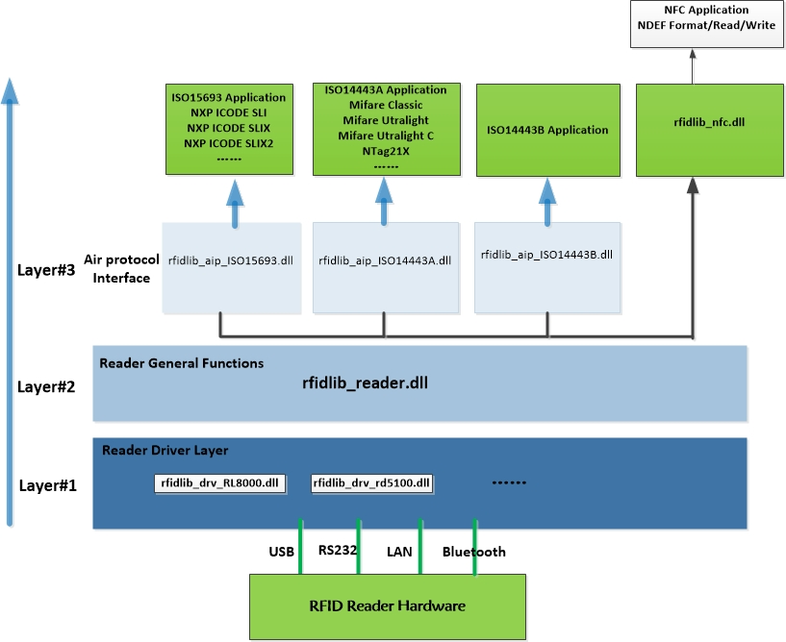

2.2. Layer#1 :Device Drivers
2.2.1. General Description
Each device model has its corresponding device driver library, you need to develop the corresponding device, just put the corresponding device driver library files are copied to the directory called “Drivers”, then when the application is initialized, calls "RDR_LoadReaderDrivers" API, load device drivers into the application, and then use the "RDR_Open" you can open the device driver, and the specific call flow, see "the development package calling process.

2.2.2. Driver list and description：
Driver Interface | Description
rfidlib_drv_RL8000.dll | RFID reader applicable to this driver including:  - Small RF power and multiple protocol, RL8600 series:  RL863，RL865, RL86P ,RL866 。  - Small RF power and ISO15693 ,RL1700 series:  RL173，RL175, RL17P ,RL176 。  - Small RF power and ISO14443A , RL1500 series:  RL153
rfidlib_drv_RD5100.dll | RFID reader applicable to this driver including:  - Large RF power and ISO15693:  RD5101,RD5104,RD5112, RD5124, RD5130,RD503 ,RD543
rfidlib_ANM201.dll | RFID reader applicable to this driver including:  - Middle RF power and ISO15693:  M201,M202 ,M20 micro ,RD201,RD202 ,PBYTJ311,PBYTJ312, TPad20
rfidlib_drv_rpan.dll | RFID reader applicable to this driver including:  1.RFID handheld inventory (R-PAN)

2.3. Layer#2: Device Common Programming Interface

Library Name | Description
rfidlib_reader.dll | Device common programming interface

2.4. Layer#3: Air protocol interface

2.4.1. Description
The function package is based on the common programming interface of the device "rfidlib_reader.dll" , defined tag access APIs and inventory parameter .

2.4.2. Supported air protocol interface
Name | Description
rfidlib_aip_iso15693.dll | ISO15693 air protocol interface ,this library including inventory parameter, icode sli acess commands ,icode slix access commands and so on .
rfidlib_aip_iso14443A.dll | ISO14443A air protocol interface,this library including inventory parameter ,mifare S50/S70 access commands ,mifare ultralight access commands and so on .
rfidlib_aip_iso18000p3m3.dll | ISO18000-3 mode 3 air protocol interface ,this library including inventory parameter and HF EPC access commands .

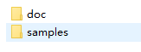

3.1. doc
This directory contains detailed documentation for all programming interfaces, which contain both Chinese documentation and English documentation.


3.2.samples
Samples directory
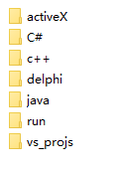
3.3.1.vs_projs
窗体顶端
Vs2005 solution sln, the solution contains all the c + + and c # project
3.3.2.c++
This directory contains MFC development samples
3.3.3.C#
This directory contains C# development samples
3.3.4.delphi
This directory contains delphi development samples
3.3.5.java
This directory contains JNI development samples
3.3.6.activeX
This directory contains OCX development samples
3.3.7.run
The directory contains c ++, C #, delphi example of the project to generate the final executable file exe and API dll file.

4. API calling step

4.1. Open reader driver
Step 1 | Copy the needing DLL files from "samples\run directory" to application execute output directory.
Step 2 | Call API "RDR_LoadReaderDrivers" to load all the device driver when application initialization from "Drivers"
Step 3 | Call API “RDR_Open” to open the special device driver by specify the device driver type in the connection string .

4.2. RFID Reader Operation

4.2.1 Tag Inventory
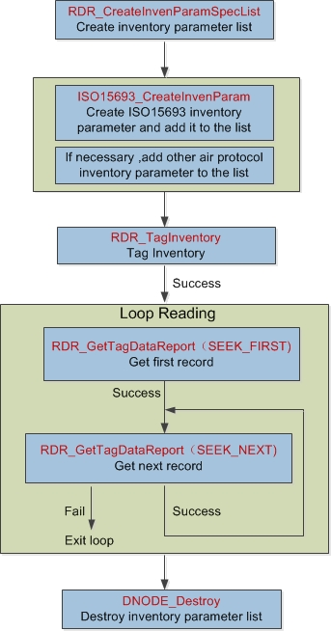

4.2.2 RFID Tag Access

4.2.2.1. Access ISO5693 tag Step
Step | Description | API name
1 | Connect Tag | ISO15693_Connect , For detail see “rfidlib_aip_iso15693.doc”
2 | ISO15693 Optional commands | ISO15693_ReadSingleBlock  ISO15693_WriteSingleBlock  ISO15693_LockBlock  ISO15693_ReadMultiBlocks  ISO15693_WriteMultipleBlocks  ISO15693_WriteAFI  ISO15693_LockAFI  ISO15693_WriteDSFID  ISO15693_LockDSFID  ISO15693_GetSystemInfo  ISO15693_GetBlockSecStatus  For detail see “rfidlib_aip_iso15693.doc”
2 | NXP ICODE SLI  Custom commands | NXPICODESLI_EableEAS  NXPICODESLI_DisableEAS  NXPICODESLI_LockEAS  NXPICODESLI_EASAlarm  For detail see “rfidlib_aip_iso15693.doc”
2 | NXP ICODE SLIX  Custom commands | NXPICODESLIX_EableEAS  NXPICODESLIX_DisableEAS  NXPICODESLIX_LockEAS  NXPICODESLIX_EASAlarm  NXPICODESLIX_GetRandomNum  NXPICODESLIX_SetPassword  NXPICODESLIX_WritePassword  NXPICODESLIX_LockPassword  NXPICODESLIX_PasswordProtect  For detail see “rfidlib_aip_iso15693.doc”
2 | Tag-it HF-I plus  Custom commands | TIHFIPLUS_Write2Blocks  TIHFIPLUS_Lock2Blocks  For detail see “rfidlib_aip_iso15693.doc”
3 | Tag disconnect | RDR_TagDisconnect  RDR_DisconnectAllTags, For detail see “rfidlib_reader.doc”

4.2.2.2 ISO14443A - Access Mifare Utralight Step
Step | Description | API
1 | Connect to tag | ULTRALIGHT_Connect,For detail,please see “rfidlib_aip_iso14443a.doc”
2 | Page access commands | ULTRALIGHT_Read  ULTRALIGHT_Write  ULTRALIGHT_LockPage  ULTRALIGHT_LockBlock  ULTRALIGHT_ReadMultiplePages  ULTRALIGHT_WriteMultiplePages  ULTRALIGHT_Authenticate  ULTRALIGHT_UpdatePassword  ULTRALIGHT_UpdateAuthConfig  For detail,please see “rfidlib_aip_iso14443a.doc”
3 | Disconnect from tag | RDR_TagDisconnect  RDR_DisconnectAllTags  For detail,please see “rfidlib_reader.doc”

4.2.2.3 ISO14443A - Access Mifare classic (S50/S70) Step
Step | Description | API
1 | Connect to tag | MFCL_Connect,For detail, please see “rfidlib_aip_iso14443a.doc”
2 | KeyA or KeyB authentication | MFCL_Authenticate,For detail, please see  “rfidlib_aip_iso14443a.doc”
3 | Data block access | MFCL_ReadBlock  MFCL_WriteBlock  MFCL_Increment  MFCL_Decrement  MFCL_Restore  MFCL_Transfer  MFCL_FormatValueBlock  For detail, please see “rfidlib_aip_iso14443a.doc”
4 | Disconnect from tag | RDR_TagDisconnect  RDR_DisconnectAllTags  For detail, please see “rfidlib_reader.doc”

4.3. NFC APIs

4.3.1 write NDEF message to tag
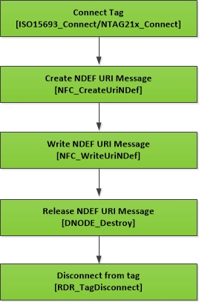

4.3.2 read NDEF message from tag
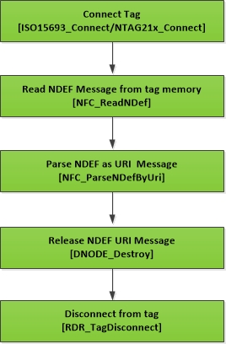

4.4. Close reader driver
Function | Memo
RDR_Close | Close reader driver and release handle

4.5. ISO15693 tag access C++ example
1.Load all reader drivers including in the “Drivers”
窗体顶端
Note: This function only needs to run once after the software starts
RDR_LoadReaderDrivers("\\Drivers") ; //
2.Open reader driver
RFID_READER_HANDLE hr;
//Build connection string
CString connstr=”RDType=RD122;CommType=USB;AddrMode=0;SerNum=”;
int iret = RDR_Open(connstr,&hr) ;
If(iret ==0) {
//open ok
}
Else {
//open fail
}
3. Inventory and Read
//tell RDR_TagInventory we want to read ISO15693 tag
RFID_DN_HANDLE dnInvenParamList= RFID_HANDLE_NULL ;
dnInvenParamList = RDR_CreateInvenParamSpecList() ;
if(dnInvenParamList){
ISO15693_CreateInvenParam (dnInvenParamList,0) ;
}
//send inventory command
iret = RDR_TagInventory(hr,1,0,NULL ,dnInvenParamList) ;
if(iret == NO_ERR) {
//inventory OK, and try to get all the tag report from local memory .
RFID_DN_HANDLE dnhReport = RDR_GetTagDataReport(hr,RFID_SEEK_FIRST) ;
while(dnhReport != RFID_HANDLE_NULL)
{
DWORD AIPtype,TagType,AntId ;
BYTE dsfid;
BYTE uid[8];
BYTE uidlen;
iret = ISO15693_ParseTagDataReport (dnhReport,&AIPtype,&TagType,&AntId,uid,&uidlen) ;
if(iret == NO_ERR) {
//try to read data blocks from tag
RFID_TAG_HANDLE hp;
iret = ISO15693_Connect(hr, TagType,1,uid,&hp);
if(iret == 0) {
// Connect OK
BYTE buffer[128*5] ;
DWORD nSize;
DWORD bytesBlkDatRead =0 ;
DWORD numOfBlksRead=0
iret= ISO15693_ReadMultiBlocks(hr,hp,TRUE,0,4,&numOfBlksRead,buffer,nSize,&bytesBlkDatRead) ;;
if(iret ==0) {
//Read blocks ok
}
//Disconnect from tag
RDR_TagDisconnect (ht,hp) ;
}
}
dnhReport = RDR_GetTagDataReport(hr,RFID_SEEK_NEXT) ;
}
}
Else{
//fail
}

if(dnInvenParamList) DNODE_Destroy(dnInvenParamList) ;

4.Close reader driver
RDR_Close(hr) ;

4.6. ISO14443A-Mifare S50 C++ example
1.Load all reader drivers including in the “Drivers”
窗体顶端
Note: This function only needs to run once after the software starts
RDR_LoadReaderDrivers("\\Drivers") ; //
2.Open reader driver
RFID_READER_HANDLE hr;
//Build connection string
CString connstr=”RDType=RD122;CommType=USB;AddrMode=0;SerNum=”;
int iret = RDR_Open(connstr,&hr) ;
If(iret ==0) {
//open ok
}
Else {
//open fail
}
3.Inventory and Read data block
//tell RDR_TagInventory we want to read ISO14443A tag
RFID_DN_HANDLE dnInvenParamList= RFID_HANDLE_NULL ;
dnInvenParamList = RDR_CreateInvenParamSpecList() ;
if(dnInvenParamList){
ISO14443A_CreateInvenParam(dnInvenParamList,0) ;
}
//send inventory command
iret = RDR_TagInventory(hr,1,0,NULL ,dnInvenParamList) ;
if(iret == NO_ERR) {
//inventory OK, and try to get all the tag report from local memory .
RFID_DN_HANDLE dnhReport = RDR_GetTagDataReport(hr,RFID_SEEK_FIRST) ;
while(dnhReport != RFID_HANDLE_NULL)
{
DWORD AIPtype,TagType,AntId ;
BYTE dsfid;
BYTE uid[8];
BYTE uidlen;
iret = ISO14443A_ParseTagDataReport(dnhReport,&AIPtype,&TagType,&AntId,uid,&uidlen) ;
if(iret == NO_ERR) {
RFID_TAG_HANDLE hp;
iret = MFCL_Connect(hr,0,uid,&hp);
if(iret == 0) {
BYTE keyType=0; //0: KEY A ,1:KEY B
BYTE key[6]={0xff,0xff,0xff,0xff,0xff,0xff} ;
iret = MFCL_Authenticate(hr,hp,44, keyType，key);
if(iret ==0) {
BYTE blockBuffer[16] ;
iret =MFCL_ReadBlock(hr,hp,44 , blockBuffer,sizeof(blockBuffer)) ;
if(iret == 0) {
//Read data block OK ,add your code here
}
}
//Disconnect from tag
RDR_TagDisconnect (ht,hp) ;
}
}
dnhReport = RDR_GetTagDataReport(hr,RFID_SEEK_NEXT) ;
}
}
Else{
//fail
}

if(dnInvenParamList) DNODE_Destroy(dnInvenParamList) ;

4.Close reader driver
RDR_Close(hr) ;

5. Connection String

5.1. Description
The connection string is made up of parameter fields, separated by a ";" semicolon. Each parameter has a name and a value separated by "=". The connection string has two basic parameters "RDType" (Reader driver type) and "CommType" (communication interface type). The name or type number of the reader driver can be obtained from the corresponding reader driver manual. Communication interface type supports serial, USB,Bluetooth and network interface.
窗体底端

5.2. Build connection string of serial port

5.2.1. Format example
“RDType=RD201; CommType=COM;COMName=COM1;BaudRate=38400;Frame=8E1;BusAddr=255”

5.2.2. Parameter description
No | Name | Parameter Value
1 | RDType | Reader driver ,this value can be either a name of driver or a type coding number . For example, want to open M201 driver , can set  RDType=M201 or RDType=690201.
2 | CommType | Communication interface type.  Set “CommType=COM“
3 | COMName | COM name, Such as “COM1“ ,“COM2“ …
4 | BaudRate | Baud rate ,such as “38400”
5 | Frame | Frame type:
5 | Frame | Value | Description
5 | Frame | “8E1“ | 8 data bits, Even,1 stop bit
5 | Frame | “8O1“ | 8 data bits, Odd,1 stop bit
5 | Frame | “8N1“ | 8 data bits, None,1 stop bit
6 | BusAddr | RS485 Bus address, 1-254，255 is broadcast address.

5.3. Build connection string of USB

5.3.1. Format example
“RDType=M201;CommType=USB;AddrMode=1;SerNum=1000011”

5.3.2. Parameter description
No | Name | Parameter value
1 | RDType | Reader driver ,this value can be either a name of driver or a type coding number . For example, want to open M201 driver , can set  RDType=M201 or RDType=690201.
2 | CommType | Communication interface type.  Set “CommType=USB“
3 | AddrMode | Address mode:
3 | AddrMode | Value | Description
3 | AddrMode | 0 | 窗体顶端  None address, automatically search the first device has been inserted USB interface, and open. If more than one device is searched for, a failure is returned.
3 | AddrMode | 1 | Use serial number of reader to open ,then the “SerNum” parameter should set to this serial number.
3 | AddrMode | 2 | Use The detail USB driver path of the reader to open, then the “SerNum” parameter should set to this driver path.
4 | SerNum | 窗体顶端  Serial number or driver path, when “AddrMode“ value is 0, the parameter will be ignored.

5.4. Build connection string of network

5.4.1. Format example
“RDType=M201; CommType=NET; RemoteIP=192.168.0.246; RemotePort=9909; LocalIP=”

5.4.2. Parameter description
No | Name | Parameter value
1 | RDType | Reader driver ,this value can be either a name of driver or a type coding number . For example, want to open M201 driver , can set  RDType=M201 or RDType=690201.
2 | CommType | Communication interface type.  Set “CommType=NET“
3 | RemoteIP | IP address of destination reader
4 | RemotePort | Socket port opened for communication
5 | LocalIP | 窗体顶端  Local IP, can be used to bind the specified network card. Do not need to pass null values.

5.5. Build connection string of Bluetooth

5.5.1. Format example
“RDType=RPAN;CommType=BLUETOOTH;Addr=00:0D:19:02:0C:DE”

5.5.2. Parameter description
NO | Name | Parameter value
1 | RDType | Reader driver ,this value can be either a name of driver or a type coding number . For example, want to open M201 driver , can set  RDType=RPAN or RDType=200001.
2 | CommType | Communication interface type.  Set “CommType=BLUETOOTH“
3 | Addr | Bluetooth name

6. Description of common API calls for the rfidlib_reader.dll

6.1. Enumerate serial ports

6.1.1. API Introduction
API Name | Description
COMPort_Enum | Enumerate the serial port installed in Windows and return the quantity. for detail, please see document “rfidlib_reader.doc”
COMPort_GetEnumItem | 窗体顶端  Obtain the serial port name of the enumerated item. for detail, please see document “rfidlib_reader.doc”

6.1.2. C# programming example
comboBox1.Items.Clear();
UInt32 nCOMCnt = COMPort_Enum();
for ( i = 0; i < nCOMCnt; i++)
{
StringBuilder comName = new StringBuilder();
comName.Append('\0', 64);
COMPort_GetEnumItem(i, comName, (UInt32)comName.Capacity);
comboBox1.Items.Add(comName);
}
if (comboBox1.Items.Count > 0) comboBox1.SelectedIndex = 0;

6.2. Enumerate the inserted USBHID Readers

6.2.1. API introduction
API Name | Description
HID_Enum | Enumerate the inserted USBHID reader and return the quantity. for detail, please see document “rfidlib_reader.doc”
HID_GetEnumItem | Obtain the serial number or driver path of the enumerated item. for detail, please see document “rfidlib_reader.doc”.

6.2.2. C# programming example
comboBox9.Items.Clear();
UInt32 nCount = HID_Enum(driver.m_name);
int iret;
int i;
for ( i = 0; i < nCount; i++)
{
StringBuilder sernum = new StringBuilder();
sernum.Append('\0', 64);
UInt32 nSize;
nSize = (UInt32)sernum.Capacity;
iret = HID_GetEnumItem((UInt32)i, HID_ENUM_INF_TYPE_SERIALNUM,
sernum,ref nSize);
if (iret == 0)
{
comboBox9.Items.Add(sernum.ToString());
}
}

6.3. Enumerate the matched Bluetooth readers

6.3.1. API introduction
API Name | Description
Bluetooth_Enum | Enumerates the matched the Bluetooth reader and returns the quantity. For details, please see "rfidlib_reader .doc"
Bluetooth_GetEnumItem | Obtain the Bluetooth name or serial number of the enumerated item. for detail, please see document “rfidlib_reader.doc”.

6.3.2. C# programming example
UInt32 nBluetooth = Bluetooth_Enum();
for (UInt32 j = 0; j < nBluetooth; j++)
{
StringBuilder nameBuf = new StringBuilder();
StringBuilder addrBuf = new StringBuilder();
UInt32 nSize = 256;
nameBuf.Append('\0', (int)nSize);
addrBuf.Append('\0', (int)nSize);
Bluetooth_GetEnumItem(j, 1, nameBuf, ref nSize);
nSize = 256;
Bluetooth_GetEnumItem(j, 2, addrBuf, ref nSize);
cbbBluetoothName.Items.Add(nameBuf);
m_blueAddrList.Add(addrBuf.ToString());
}

6.4. Enumerates the loaded RFID reader driver

6.4.1. API introduction
API Name | Description
RDR_GetLoadedReaderDriverCount | 窗体顶端  Get the number of loaded reader drivers. For details, please see "rfidlib_reader .doc"
RDR_GetLoadedReaderDriverOpt | 窗体顶端  Get the parameter information of the reader driver.  For details, please see "rfidlib_reader .doc"

6.4.2. C# Programming example
Note: Before enumerating the loaded reader driver, make sure that the API
"RDR_LoadReaderDrivers" is called.

UInt32 nCount;
nCount = RDR_GetLoadedReaderDriverCount(); //Get the quantity
uint i;
for( i=0;i<nCount;i++){
UInt32 nSize;
CReaderDriverInf driver = new CReaderDriverInf();
StringBuilder strCatalog = new StringBuilder();
strCatalog.Append('\0', 64);
nSize = (UInt32)strCatalog.Capacity;
//Get the class of the reader driver ,type can be reader class ,meeting gate class or library security gate class .
RDR_GetLoadedReaderDriverOpt(i, LOADED_RDRDVR_OPT_CATALOG, strCatalog, ref nSize);
driver.m_catalog = strCatalog.ToString();
if (driver.m_catalog == RDRDVR_TYPE_READER) //is reader class ?
{
//Get name of the reader driver, such as ”M201”
StringBuilder strName = new StringBuilder();
strName.Append('\0', 64);
nSize = (UInt32)strName.Capacity;
RDR_GetLoadedReaderDriverOpt(i, LOADED_RDRDVR_OPT_NAME, strName, ref nSize);
driver.m_name = strName.ToString();
//Get type coding of the reader driver, such as ”680201”
StringBuilder strProductType = new StringBuilder();
strProductType.Append('\0', 64);
nSize = (UInt32)strProductType.Capacity;
RDR_GetLoadedReaderDriverOpt(i, LOADED_RDRDVR_OPT_ID, strProductType, ref nSize);
driver.m_productType = strProductType.ToString();
//Get supported communication port of the driver
StringBuilder strCommSupported = new StringBuilder();
strCommSupported.Append('\0', 64);
nSize = (UInt32)strCommSupported.Capacity;
RDR_GetLoadedReaderDriverOpt(i, LOADED_RDRDVR_OPT_COMMTYPESUPPORTED,
strCommSupported, ref nSize);
driver.m_commTypeSupported = (UInt32)int.Parse(strCommSupported.ToString());
readerDriverInfoList.Add(driver);
}
}

6.5. RS485 Bus programming

6.5.1. Description
RS485 bus uses the same serial port to communicate with multiple readers synchronously, so all the drivers of the reader of RS485 bus must share the same communication layer. First, open the corresponding reader driver with API "RDR_Open" , and then call the API "RDR_CreateRS485Node" to create RS485 nodes, all the created RS485 Nodes share the same communication layer, the API description see "rfidlib_reader.doc".
窗体底端

6.5.2. C++ programming example
int iret ;
RFID_READER_HANDLE hANRD201;
RFID_READER_HANDLE hRS485_R1;
RFID_READER_HANDLE hRS485_R2;
RFID_READER_HANDLE hRS485_R3;

RDR_LoadReaderDrivers(“\\Drivers”) ;
//initial all RS485 Node to NULL
hANRD201= hRS485_R1= hRS485_R2= hRS485_R3 = NULL;
//Open RS485 bus communication layer
iret = =RDR_Open(”RDType=RD201;CommType=COM;COMName=COM5;BaudRate=38400;Frame=8E1;BusAddr=255,&hANRD201);
if(iret != 0) {
// open fail;
goto exit_func;
}
// Create first RS485 Node
iret = RDR_CreateRS485Node(hANRD201 , 1,&hRS485_R1) ;
if(iret !=0) {
// create fail;
goto exit_func;
}
//Create second RS485 node
iret = RDR_CreateRS485Node(hANRD201 , 2,&hRS485_R2) ;
if(iret !=0) {
// create fail;
goto exit_func;
}
//Create third RS485 node
iret = RDR_CreateRS485Node(hANRD201 , 3,&hRS485_R3) ;
if(iret !=0) {
// create fail;
goto exit_func;
}

//reader command process here ..........

.........................................
// program exit
exit_func:
//close first RS485 node
if(hRS485_R1) {
RDR_Close(hRS485_R1) ;
}
//close second RS485 node
if(hRS485_R2) {
RDR_Close(hRS485_R2) ;
}
//close third RS485 node
if(hRS485_R3) {
RDR _Close(hRS485_R3) ;
}
//Close communication layer
if(hANRD201)
{
RDR_Close(hANRD201) ;
}

6.6. GPIO output control

6.6.1. API introduction
API Name | Description
RDR_CreateSetOutputOperations | Create collection node of GPIO output control descriptor ,detail please see document”rfidlib_reader.doc”
RDR_AddOneOutputOperation | Add a new GPIO output control descriptor to collection node ,detail please see document”rfidlib_reader.doc”
RDR_SetOutput | 窗体顶端  A control command is sent to the RFID reader in accordance  with the output control description ,  detail please see document”rfidlib_reader.doc”

6.6.2. API calling process
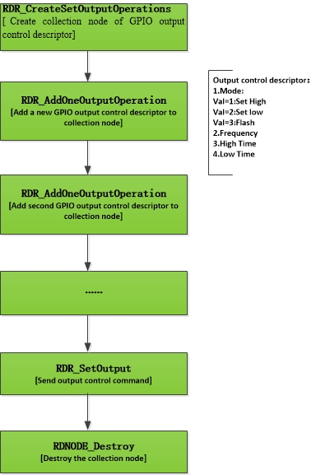

6.6.3. C++ programming example
RFID_DN_HANDLE hOutputOperations;
BYTE outputNO; /* Output port Number,about output port number supported by reader please see reader driver manual */
BYTE contrlMode ;/* Control mode: 1:Set high,2:set low,3:flash*/
BYTE frequency ;/*frequency of flash*/
BYTE activeDuration ; /* time for staying high */
BYTE inactiveDuration; /* time for staying low */
int iret;
outputNo = 1;
contrlMode=3;
frequency =2 ;/* flash two time */
activeDuration = 1 ;
inactiveDuration = 1;
hOutputOperations = RDR_CreateSetOutputOperations() ;
if(hOutputOperations) {
RDR_AddOneOutputOperation(hOutputOperations ,
outputNO, contrlMode, frequency, activeDuration, inactiveDuration) ;
iret = RDR_SetOutput(hr , hOutputOperations) ;
if(iret == 0) {
/* Set output ok */
}
/* Release collection node */
DNODE_Destroy (hOutputOperations) ;
}

6.7. Get Input GPIO status
Call API RDR_GetGPIsStatus to get input GPIO status.

6.8. Get device information
Call API “RDR_GetReaderInfor” to get device information.

6.9. Read/write configuration block
APIs：
1 | RDR_ConfigBlockWrite | Write configuration block
2 | RDR_ConfigBlockRead | Read configuration block
3 | RDR_ConfigBlockSave | Save configuration block

6.10. To fetch buffer record in Buffer mode
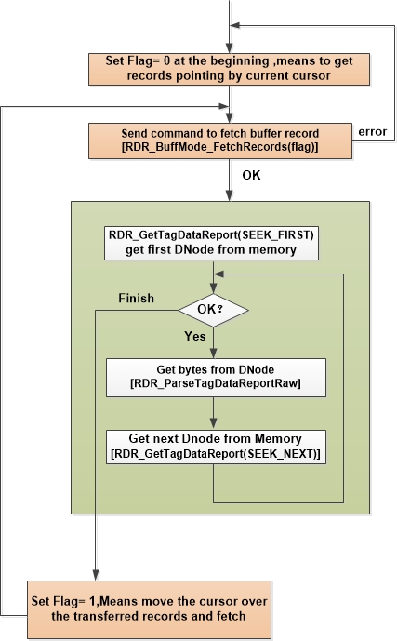

1.1. Variable Type Description
Name | Length | Description
BOOLEAN | 1 | 0:FALSE,1:TRUE;
BYTE | 1 | Byte ,range is 0-255
WORD | 2 | Word，range is 0-65535
DWORD | 4 | Double word, range is 0- 4294967295
err_t | 4 | Integer
WPARAM | 4 or 8 | Unsigned integer in 32 bits windows ,  Unsigned integer 64 in 64 bits windows .
LPARAM | 4 or 8 | Unsigned integer in 32 bits windows ,  Unsigned integer 64 in 64 bits windows
HWND | 4 or 8 | Unsigned integer in 32 bits windows ,  Unsigned integer 64 in 64 bits windows
WIN_MSG_t | 4 or 8 | Unsigned integer
RFID_EVENT_CALLBACK | 4 or 8 | Pointer to call back function
LPCTSTR | N | Const string
LPTSTR | N | Character buffer to store string .
RFID_READER_HANDLE | 4 or 8 | RFID reader handle
RFID_TAG_HANDLE | 4 or 8 | RFID tag handle
RFID_DN_HANDLE | 4 or 8 | RFID data node handle
BYTE [ ] | 4 or 8 | Byte array,use to input or output multiple bytes data .
BYTE * | 4 or 8 | Byte reference ,use to output single byte data
WORD * | 4 or 8 | Word reference ,use to output word data
DWORD * | 4 or 8 | Double word reference ,use to output double word data.
RFID_READER_HANDLE * | 4 or 8 | RFID reader handle reference ,use to output RFID reader handle .
RFID_TAG_HANDLE * | 4 or 8 | RFID tag handle reference ,use to output tag handle.
RFID_DN_HANDLE * | 4 or 8 | RFID data node handle reference ,use to output data node handle .

1.2. Variable type defined in C++
Name | Definition
BOOLEAN | unsigned char
BYTE | unsigned char
WORD | unsigned short
DWORD | unsigned int
err_t | int
WPARAM | 32 bits: unsigned int  64 bits: unsigned __int64
LPARAM | 32 bits: unsigned int  64 bits: unsigned __int64
HWND | 32 bits: unsigned int  64 bits: unsigned __int64
WIN_MSG_t | 32 bits: unsigned int  64 bits: unsigned __int64
RFID_EVENT_CALLBACK | VOID (__stdcall *RFID_EVENT_CALLBACK)(WPARAM wparam, LPARAM lparam) ;
LPCTSTR | ANSI: const char * ;  unicode: const wchar * ;
LPTSTR | ANSI: char * ;  unicode: wchar * ;
RFID_READER_HANDLE | 32 bits: unsigned int  64 bits: unsigned __int64
RFID_TAG_HANDLE | 32 bits: unsigned int  64 bits: unsigned __int64
RFID_DN_HANDLE | 32 bits: unsigned int  64 bits: unsigned __int64
BYTE [] | unsigned char variable[ ]
BYTE * | unsigned char *
WORD * | unsigned short *
DWORD * | unsigned int *
RFID_READER_HANDLE * | 32 bits: unsigned int *  64 bits: unsigned __int64 *
RFID_TAG_HANDLE * | 32 bits: unsigned int *  64 bits: unsigned __int64 *
RFID_DN_HANDLE * | 32 bits: unsigned int *  64 bits: unsigned __int64 *

1.3. Variable type defined in C#
Name | Definition
BOOLEAN | Byte
BYTE | Byte
WORD | UInt16
DWORD | UInt32
err_t | int
WPARAM | UIntPtr
LPARAM | UIntPtr
HWND | UIntPtr
WIN_MSG_t | Uint32
RFID_EVENT_CALLBACK | Public delegate void  RFIDLIB_EVENT_CALLBACK(UIntPtr wparam, UIntPtr lparam);
LPCTSTR | string
LPTSTR | StringBuilder
RFID_READER_HANDLE | UIntPtr
RFID_TAG_HANDLE | UIntPtr
RFID_DN_HANDLE | UIntPtr
BYTE [ ] | Byte[ ]
BYTE * | ref Byte
WORD * | ref UInt16
DWORD * | ref UInt32
RFID_READER_HANDLE * | ref UIntPtr
RFID_TAG_HANDLE * | ref UIntPtr
RFID_DN_HANDLE * | ref UIntPtr

1.4. Variable type defined in delphi
Name | Definition
BOOLEAN | byte
BYTE | byte
WORD | word
DWORD | longword
err_t | integer
WPARAM | longword
LPARAM | longword
HWND | longword
WIN_MSG_t | longword
RFID_EVENT_CALLBACK | procedure(wParam: longword; lParam: longword) ; stdcall;
LPCTSTR | string
LPTSTR | pchar
RFID_READER_HANDLE | longword
RFID_TAG_HANDLE | longword
RFID_DN_HANDLE | longword
BYTE [] | PBYTE ,type PBYTE=^byte ;
BYTE * | var byte
WORD * | var word
DWORD * | var longword
RFID_READER_HANDLE * | var longword
RFID_TAG_HANDLE * | var longword
RFID_DN_HANDLE * | var longword

1.5. Variable type defined in VB
Name | Definition
BOOLEAN | Byte
BYTE | Byte
WORD | Integer
DWORD | Long
err_t | Long
WPARAM | Long
LPARAM | Long
HWND | Long
WIN_MSG_t | Long
RFID_EVENT_CALLBACK
LPCTSTR | String
LPTSTR | Fixed length String, Dim str1 As String * n(n is max character count to store)
RFID_READER_HANDLE | long
RFID_TAG_HANDLE | long
RFID_DN_HANDLE | long
BYTE [] | ByRef x as byte
BYTE * | ByRef x as byte
WORD * | ByRef x as integer
DWORD * | ByRef x as long
RFID_READER_HANDLE * | ByRef x as long
RFID_TAG_HANDLE * | ByRef x as long
RFID_DN_HANDLE * | ByRef x as long

1.6. Variable type defined in VB.net
Name | Definition
BOOLEAN | Byte
BYTE | Byte
WORD | UInt16
DWORD | UInt32
err_t | integer
WPARAM | UIntPtr
LPARAM | UIntPtr
HWND | UIntPtr
WIN_MSG_t | Uint32
RFID_EVENT_CALLBACK | Public delegate Sub  RFIDLIB_EVENT_CALLBACK(byval wparam as UIntPtr, byval lparam as UIntPtr)
LPCTSTR | String
LPTSTR | StringBuilder
RFID_READER_HANDLE | UIntPtr
RFID_TAG_HANDLE | UIntPtr
RFID_DN_HANDLE | UIntPtr
BYTE [ ] | ref Byte
BYTE * | ref Byte
WORD * | ref UInt16
DWORD * | ref UInt32
RFID_READER_HANDLE * | ref UIntPtr
RFID_TAG_HANDLE * | ref UIntPtr
RFID_DN_HANDLE * | ref UIntPtr

Appendix 2. Air protocol type and Tag type coding

2.1.Air protocol type code definition
Type | Code | Memo
HF ISO15693 | 1 | ISO18000-3 mode1
HF ISO14443A | 2
HF ISO14443B | 3
UHF EPC | 4 | ISO18000-6C
HF ISO18000-3 mode 3 | 5

2.2. Tag type code definition

2.2.1. ISO15693
Tag Type | ID | Memo
NXP ICODE SLI | 1 | SL2S2001
Tag-it HF-I plus | 2
ST M24LRxx | 3 | ST M24LR 系列。
Fujitsu MB89R118C | 4
ST M24LR64 | 5
ST M24LR16E | 6
NXP ICODE SLIX | 7 | SL2S2002 / SL2S2102
Tag-it HF-I Standard | 8
Tag-it HF-I Pro | 9

2.2.2. ISO14443A
Tag Type | ID
Mifare ultralight and ultralight C | 1
Mifare S50 | 2
Mifare S70 | 3

Appendix 3. RFIDLIB API error table
Error | Description
0 | No error
-1 | Unknown error
-2 | IO error
-3 | Parameter error
-4 | Parameter value error
-5 | Reader respond timeout
-6 | Memory allocation fail
-7 | Reserved
-8 | Reserved
-9 | Reserved
-10 | Reserved
-11 | Reserved
-12 | Invalid message size from reader
-13 | Reserved
-14 | Reserved
-15 | Reserved
-16 | Reserved
-17 | Error from reader,  can use “RDR_GetReaderLastReturnError” to get reader error code .
-18 | Reserved
-19 | Reserved
-20 | Reserved
-21 | Timeout stop trigger occur .
-22 | Invalid tag command
-23 | Invalid Configuration block No
-24 | Reserved
-25 | TCP socket error
-26 | Size of input buffer too small.
-27 | Reserved

